 CHEMICAL ENGINEERING TRANSACTIONS  VOL. xxx, 2026 | A publication of  
The Italian Association
of Chemical Engineering
Online at www.cetjournal.it

Guest Editors: Leonardo Tognotti, Rubens Maciel Filho, Viatcheslav Kafarov
Copyright © 2026, AIDIC Servizi S.r.l.
ISBN 979-12-81206-xx-x; ISSN 2283-9216

Experimental and Thermodynamic Assessment of Caryocar Brasiliense (Pequi) Stone for Hydrogen Production via Supercritical Water Gasification
Maristella dos Santos Montelesª, Lucas Pinheiro dos Reisª, Diana Silva da Costaª, Julles Mitoura dos Santos Júnior^{c}, Dennys Correia da Silvaª, Thiago Vinícius Barros^{b}, Annamaria Dória Souza Vidottiª, Antonio Carlos Daltro de Freitasª and Reginaldo Guirardello^{c},*
ªDepartment of Chemical Engineering, Center for Exact Sciences and Technology, Federal University of Maranhão (UFMA), Av. dos Portugueses, 1966, Bacanga, São Luís 65080-805, Brazil
^{b}Department of Chemical Engineering, Center of Technology, State University of Maringá (UEM), Av. Colombo 5790, Maringá 87020-900, Brazil
^{c}School of Chemical Engineering (FEQ), State University of Campinas (UNICAMP), Av. Albert Einstein 500, Campinas 13083-852, Brazil
guira@feq.unicamp.br
The growing demand for sustainable energy carriers highlights hydrogen as a key component in the global energy transition. This study investigates Caryocar brasiliense (pequi) stone as a renewable feedstock for hydrogen production via supercritical water gasification (SCWG). Experimentally, the biomass was characterized through proximate and ultimate analyses, higher heating value determination, and Fourier-transform infrared spectroscopy (FTIR). The results indicate that pequi stone exhibits low moisture content (6.74%), high volatile matter (91.31%), favourable H/C (1.63) and O/C (0.51) molar ratios, and a chemically labile lignocellulosic structure rich in oxygenated and hydrogen-containing functional groups, confirming its suitability for thermochemical conversion. Complementarily, thermodynamic equilibrium simulations were performed using the TeS v3 free software under isothermal (Gibbs energy minimization) and adiabatic (entropy maximization) conditions. The simulations confirm the feasibility of hydrogen-rich gas production from pequi stone, with hydrogen molar fractions exceeding 50% under both isothermal and adiabatic operation, particularly at elevated temperatures and low biomass loadings. Overall, the combined experimental characterization and thermodynamic assessment demonstrate that pequi stone is a promising biomass for sustainable hydrogen production via SCWG, reinforcing its potential relevance for decentralized energy strategies in biomass-rich areas such as the Amazonian region of Maranhão, Brazil.
- Introduction
The transition toward low-carbon energy systems has intensified interest in hydrogen as a clean energy carrier capable of supporting decarbonization across industrial, transportation, and power generation sectors (IPCC, 2022). Among the available production routes, thermochemical conversion of renewable biomass has gained prominence due to its potential to couple energy generation with waste valorization and carbon mitigation, particularly when integrated with advanced conversion technologies (Castello and Fiori, 2011).
Supercritical water gasification (SCWG) is a promising route for hydrogen production from wet and heterogeneous biomasses, as it avoids energy-intensive drying while maintaining high conversion efficiencies (Antal et al., 2000). By operating above the critical point of water, the process enhances the rapid decomposition of organic matter and promotes reforming reactions that increase hydrogen yield, while reducing char formation and mass-transfer limitations typical of conventional gasification processes (Elliot et al., 2004).
In this context, the use of regionally available biomass residues is essential to improve the techno-economic and environmental viability of SCWG systems. Caryocar brasiliense (pequi) stone, an abundant agro-extractivist residue in Maranhão and other Amazonic regions, represents an underexplored feedstock with attractive physicochemical characteristics for thermochemical conversion. Its valorization for hydrogen production aligns with circular economy principles and contributes to the sustainable management of local biomass resources.
This study presents an integrated experimental and thermodynamic assessment of pequi stone for hydrogen production via SCWG. Comprehensive physicochemical characterization is combined with thermodynamic equilibrium modelling under isothermal and adiabatic conditions using Gibbs energy minimization and entropy maximization approaches. By coupling experimental evidence with thermodynamic insights, the work aims to evaluate the suitability of pequi stone as a renewable feedstock and to identify favourable operating conditions for hydrogen-rich gas production, with relevance to decentralized energy strategies in biomass-rich regions, including Maranhão.
2. Methodology
2.1 Sample preparation
Pequi fruits (Caryocar brasiliense) were collected in the municipality of Anapurus, Maranhão, Brazil (3°40′19″ S and 43°06′57″ W), located in the Amazon region of the state of Maranhão. After manual removal of the outer peel, the fruits were frozen to ensure preservation until the beginning of the analyses. The pulp was removed, and the residual fractions (stones) were ground in a hammer mill (model TE-330, Tecnal) for 2 minutes. The milling process resulted in two distinct fractions: (i) a fraction composed of the spiny endocarp, containing spines and adhered pulp residues, and (ii) the fraction corresponding to the internal kernel. Because the kernel could not be reproducibly comminuted to the target size range, subsequent analyses were conducted on the spiny endocarp fraction to ensure granulometric uniformity and analytical repeatability.
The material was dried by natural convection at room temperature for 24 h, a mild procedure adopted to minimize thermal degradation and compositional alterations that could affect proximate analysis, while still ensuring sufficient moisture removal for reproducible measurements. The material was then subjected to granulometric separation using an electromagnetic sieve shaker operating for 15 minutes. The fraction retained on the 35-mesh sieve showed a higher concentration of endocarp residues, characterized by a fine yellowish powder, and was selected for characterization, stored in a Ziploc-type plastic bag, and properly labeled.
2.2 Proximate analysis
Moisture, ash, volatile matter, and fixed carbon contents of pequi stone samples were quantified according to standard ASTM procedures (ASTM D3172-13; ASTM D3173-11; ASTM D3174-12; ASTM D3175-20). All determinations were performed in triplicate, using porcelain crucibles previously dried in a convection oven, cooled in a desiccator, and weighed before use.
2.3 Ultimate analysis
An Instrument CHNS analyzer (Vario Macro Cube CHNS) was used to perform the ultimate analysis by total oxidation of biomass samples. Weight percentages of Carbon (C), Hydrogen (H), Nitrogen (N) and Sulphur (S) were determined. Oxygen contents were calculated by subtracting the sum of C, H, N and S contents from 100%.
2.4 FTIR spectroscopy
The structural characterization of the samples was carried out by Fourier-transform infrared spectroscopy (FTIR) using a Shimadzu IRPrestige-21 spectrophotometer (Shimadzu Corporation, Japan) equipped with a DTGS detector and a globar (SiC) source. The instrument was fitted with a diamond/ZnSe ATR accessory operating in direct contact with the sample surface. Spectra were recorded in the 4000–400 cm⁻¹ range, with a spectral resolution of 4 cm⁻¹ and 32 accumulated scans per sample. Prior to each acquisition, the crystal surface was carefully cleaned with analytical-grade ethanol and checked to ensure the absence of background contamination. A background spectrum was collected every five samples to ensure signal stability.
2.5 Thermodynamic Analysis
The thermodynamic behavior of the SCWG system was evaluated using two complementary equilibrium approaches. Under isothermal conditions, the equilibrium composition was determined by minimizing the total Gibbs energy (MinG, Eq. 1), at constant T and P, subject to the elemental balance and non-negativity constraints (Eqs. 3 and 5). In this formulation, the equilibrium is calculated by the minimization of the total Gibbs energy considering all possible phases. For adiabatic operation, the system behavior was assessed through entropy maximization (MaxS, Eq. 2), subject to the elemental balance, the enthalpy constraint and non-negativity of the number of moles (Eqs. 3, 4, and 5). In the MaxS formulation, the equilibrium is calculated by the maximization of total entropy under constant pressure and total enthalpy, achieving a uniform temperature. Both approaches were implemented as nonlinear programming problems, ensuring thermodynamic consistency across operating conditions. The combined application of the MinG and MaxS methods is essential for adequately representing the thermodynamic performance of SCWG systems, as it enables the prediction of equilibrium composition and thermal behavior under different operational modes (dos Santos Junior et al., 2025).
$$minG=\sum_{i=1}^{NC}{n_{i}^{g}μ_{i}^{g}}+\sum_{i=1}^{NC}{n_{i}^{l}μ_{i}^{l}}+\sum_{i=1}^{NC}{n_{i}^{s}μ_{i}^{s}}$$ | (1)
$$maxS=\sum_{i=1}^{NC}{n_{i}^{g}S_{i}^{g}}+\sum_{i=1}^{NC}{n_{i}^{l}S_{i}^{l}}+\sum_{i=1}^{NC}{n_{i}^{s}S_{i}^{s}}$$ | (2)
$$\sum_{i=1}^{NC}{a_{mi}\left(n_{i}^{g}+n_{i}^{l}+n_{i}^{s}\right)=}\sum_{i=1}^{NC}{a_{mi}n_{i}^{0}}, m=1,…,NE$$ | (3)
$$\sum_{I=1}^{NC}{\left(n_{i}^{g}H_{i}^{g}+n_{i}^{l}H_{i}^{l}+n_{i}^{s}H_{i}^{s}\right)}=\sum_{i=1}^{NC}{n_{i}^{0}H_{i}^{0}}=H^{0} , T≥0$$ |  | (4)
$$n_{i}^{g},n_{i}^{l},n_{i}^{s}≥0$$ |  | (5)
A total of 15 potential components were considered in the SCWG equilibrium modeling, representing the main compounds expected to form during biomass gasification, based on consolidated evidence from literature (Li et al., 2022) including: H₂O, H₂, CH₄, CO₂, CO, O₂, N₂, CH₄O, C₂H₆, C₃H₈, NH₃, SO₂, SO₃, H₂S and C₂H₄. Pure solid carbon (C_{(s)}) was considered as the unique component in the solid phase. The SCWG process was evaluated under temperatures ranging from 450 to 750 °C, pressures between 25 and 35 MPa, and biomass loadings from 3 to 15 wt%, conditions selected to represent realistic reactor environments, capture thermal severity effects, ensure supercritical water density, and assess hydrogen yield, carbon conversion, and overall system thermodynamic behavior (Barros et al., 2022).
The NLP problems were solved using TeS (Thermodynamic Equilibrium Simulation) free software combined with the IPOPT solver, chosen due to its suitability for highly nonlinear thermodynamic systems, capability to handle large-scale optimization problems, and robustness in systems involving complex phase interactions. IPOPT has demonstrated high accuracy and computational efficiency in thermodynamic equilibrium simulations and in systems governed by non-smooth behavior (dos Santos Júnior et al., 2025). The non ideal behavior of the system was represented using the Peng Robinson equation of state. More details about the thermodynamic formulation can be found in dos Maia et al. (2024) and in Costa et al. (2025).
3. Results and Discussion
Figure 1 shows optical micrographs of the processed pequi stone at 2× and 100× magnification, highlighting particle-size heterogeneity and surface fragmentation induced by milling and sieving.
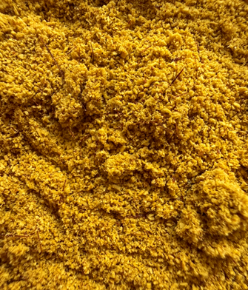(a) | (b)
Figure 1. Optical micrographs of processed pequi stone with 2x (a) and 100x (b) zoom.
3.1 Compositional and elemental Analysis
Table 1 summarizes the proximate and elemental characteristics of pequi stone in comparison with benchmark lignocellulosic residues commonly employed in thermochemical conversion studies, namely sugarcane bagasse (Athira et al., 2021), rice husk (Mansaray and Ghaly, 1998), and green coconut fiber (Sofán-Germán et al., 2025). The results reveal marked contrasts among the feedstocks. Pequi stone exhibits moderate moisture content, comparable to typical agricultural biomasses and lower than the characteristically higher values reported for rice husk, suggesting reduced energetic penalties associated with feedstock drying. Its volatile matter content is remarkably high, indicating strong devolatilization propensity and enhanced reactivity under thermochemical conditions, exceeding that of sugarcane bagasse and closely approaching the behavior of more labile residues such as green coconut fiber.
From an operational standpoint, the low ash content of pequi stone represents a significant advantage, remaining well below the elevated mineral fractions commonly observed for rice husk, which may exceed 18% (Mansaray and Ghaly, 1998). This feature is particularly relevant for gasification-based routes, as it reduces the likelihood of slagging, fouling, and mineral-induced process instabilities. Elemental analysis further indicates a relatively high carbon and hydrogen content, reflected in favorable H/C and O/C ratios and resulting in a superior higher heating value compared with the reference biomasses. The relatively high nitrogen content (4.04%) may be attributed to residual proteinaceous compounds from the adhered pulp or to inherent variability in the biomass composition, although analytical uncertainties cannot be ruled out. Likewise, the sulfur content (0.409%), although higher than typically reported for lignocellulosic materials, is relevant as it may contribute to H₂S formation during SCWG, an aspect considered in the thermodynamic analysis. During simulations, the molecule of Pequi stone was represented as a pseudocomponent, using the composition presented in Table 1.
Table 1. Proximate and elemental analyses of pequi stone compared with benchmark lignocellulosic biomasses commonly employed in thermochemical conversion studies.
Analysis | Pequi stone | Sugarcane bagasse | Rice husk | Green coconut husk
Proximate analysis (wt%)
Moisture | 6.744 $±$0.138² | 4.044 | 8.640 | 11.280
Volatile matter | 91.312 $±$0.488 | 72.198 | 71.230 | 91.810
Ash | 1.473$±$ 0.187 | 4.292 | 18.000-21.400 | 2.310
Fixed carbon | 0.470 $±$0.351 | 20.467 | 7.300 | 5.880
Elemental analysis (wt%)
Carbon | 51.783 $±$0.497 | 42.130 | 41.300 | 44.830
Hydrogen | 7.100$±$ 0.049 | 5.370 | 5.110 | 6.160
Sulfur | 0.409 $±$1.284 | 0.028 | 0.022 | -
Nitrogen | 4.043$±$ 0.011 | 0.480 | 0.450 | 0.790
Oxygen¹ | 35.191 | 47.740 | 33.470 | 48.220
O/C ratio | 0.510 | 0.851 | 0.607 | 0.769
H/C ratio | 1.633 | 1.519 | 1.474 | 1.637
HHV (MJ/Kg) * | 22.985 | 16.004 | 16.567 | 18.101
¹Determined by difference$;$ ² mean ± standard deviation (n = 3); *Calculated using the Channiwala and Parikh (2002) equation: $HHV \left(\frac{MJ}{Kg}\right)=0.3491C+1.1783H+0.1005S-0.1035O-0.015N-0.0211Ash$;
  - FTIR analysis
Figure 2 shows the FTIR spectrum of pequi stone, which is characteristic of lignocellulosic biomass and highlights functional groups relevant to its thermochemical behavior. The broad band at 3400–3200 cm⁻¹ is attributed to O–H stretching of hydroxyl groups from cellulose, hemicellulose, lignin, and residual moisture, indicating a polar and reactive matrix. The intense absorptions in the 2920–2850 cm⁻¹ region correspond to aliphatic C–H stretching vibrations, revealing a significant content of hydrogen-rich organic structures that act as primary hydrogen donors during supercritical water gasification. Bands observed between 1730–1650 cm⁻¹ are associated with C=O stretching of carbonyl and carboxyl groups, while signals in the 1600–1500 cm⁻¹ range correspond to aromatic skeletal vibrations of lignin. Additionally, strong absorptions in the 1200–1000 cm⁻¹ region, attributed to C–O and C–O–C bonds of polysaccharides, indicate a chemically labile structure prone to rapid depolymerization under supercritical conditions. Overall, the spectrum indicates abundant hydroxyl, carbonyl/carboxyl, and ether linkages typical of lignocellulosic matrices, which are thermochemically labile under supercritical conditions and consistent with reforming- and shift-favourable feeds.
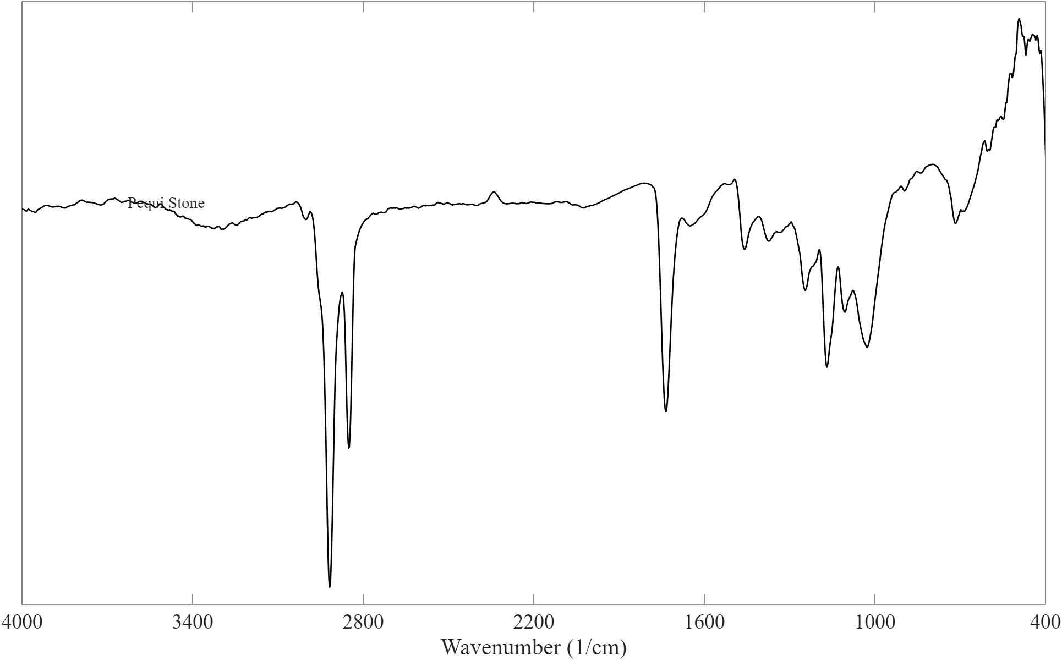
Figure 2. FTIR spectrum of Caryocar brasiliense (pequi) stone.
  - Thermodynamic modelling
Figure 3 presents the thermodynamic evaluation of hydrogen production from pequi stone via supercritical water gasification (SCWG), comparing Gibbs energy minimization (MinG) and entropy maximization (MaxS) approaches. In both formulations, the H₂ molar fraction increases monotonically with temperature, indicating the thermodynamic favourability of endothermic reactions typical of SCWG, such as steam reforming and the water–gas shift reaction. Biomass concentration exerts a strong influence on hydrogen yield. Lower loadings (3–5 wt%) result in higher H₂ molar fractions, whereas increasing the concentration to 10–15 wt% leads to a significant decrease in hydrogen production due to competition for water as a reforming agent and the enhanced formation of CO, CO₂, and CH₄. Systematically, the MaxS approach predicts higher hydrogen fractions than MinG, particularly at elevated temperatures, indicating that adiabatic constraints can shift the equilibrium toward higher H₂ fractions, providing an idealized benchmark (upper bound) for thermally coupled SCWG operation.
Spearman analyses (Figures 3c–d) indicate that hydrogen-rich equilibria are strongly driven by temperature and by the suppression of methane (methanation pathways), consistent with reforming- and shift-controlled chemistry, while pressure shows a comparatively minor influence within the investigated range (25–35 MPa). Under the MinG formulation, hydrogen exhibits strong positive correlation with CO and negative correlations with CH₄ and CO₂, reflecting the dominance of reforming reactions under isothermal conditions. In contrast, the MaxS formulation reveals a strong association between hydrogen and equilibrium temperature, highlighting thermo-chemical coupling under adiabatic operation.
FTIR results corroborate these trends, evidencing a chemically labile, oxygenated, and hydrogen-rich matrix that explains the high hydrogen yields predicted by both formulations, particularly under MaxS conditions. Overall, hydrogen production is maximized at high temperatures and low biomass loadings. Additionally, equilibrium calculations indicate negligible char formation (<10⁻⁵ mol), confirming gas-phase predominance, and no H₂S formation was predicted under the evaluated conditions.
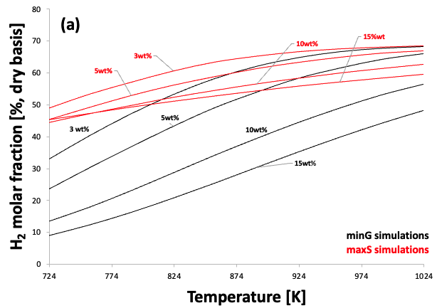 | 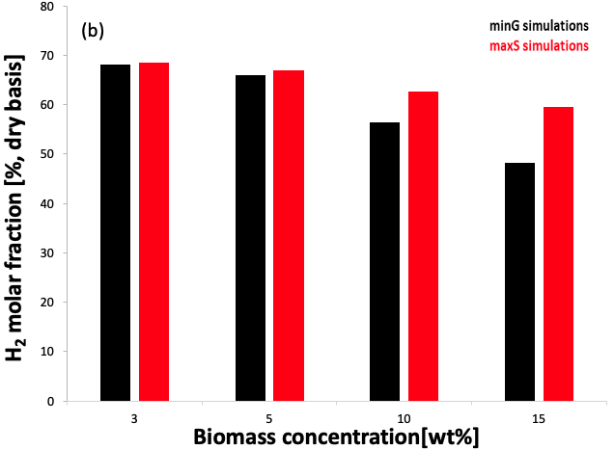
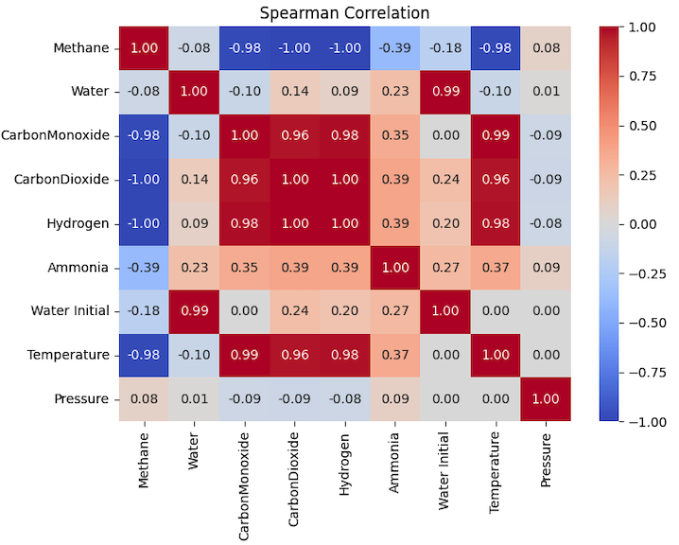(c) | 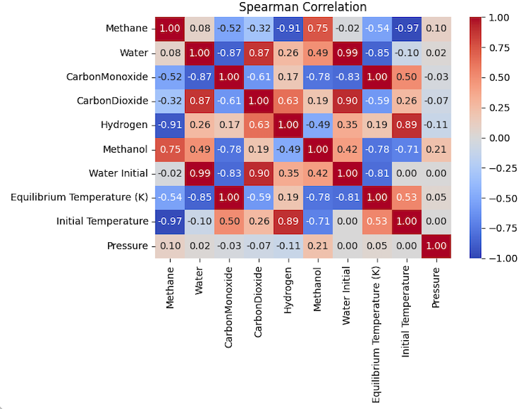(d)
Figure 3. Thermodynamic evaluation of hydrogen production from pequi stone via supercritical water gasification. (a) Effect of temperature on hydrogen molar fraction under MinG (isothermal) and MaxS (adiabatic) conditions. (b) Influence of biomass concentration on hydrogen molar fraction. (c) Spearman correlation matrix for the MinG formulation. (d) Spearman correlation matrix for the MaxS formulation.
- Conclusions
Caryocar brasiliense (pequi) stone showed significant potential as a feedstock for hydrogen production via SCWG. Its low moisture and ash contents, high volatile matter, and favourable elemental composition indicate good suitability for thermochemical conversion with reduced pretreatment demand. FTIR results also confirmed the presence of chemically labile oxygenated and hydrogen-rich functional groups, consistent with its reactivity under supercritical water. Thermodynamic simulations indicated that hydrogen-rich gas production is favoured at high temperatures and low biomass loadings, with H₂ molar fractions above 50% predicted at 25 MPa, temperatures above 923.15 K, and biomass concentrations below 10 wt%. Higher biomass loadings decreased H₂ selectivity due to increased formation of CO, CO₂, and CH₄. In addition, the MaxS approach predicted systematically higher H₂ fractions than MinG, emphasizing the importance of adiabatic effects. Overall, pequi stone emerges as a promising residue for renewable hydrogen production and deserves further experimental validation and process optimization.
Nomenclature
SCWG – Supercritical water gasification
FTIR – Fourier-transform infrared spectroscopy
MinG – Gibbs energy minimization
MaxS – Entropy maximization
NLP – Nonlinear programming
G – Total Gibbs energy of the system, J
$S$ – Total entropy of the system, J·K⁻¹
$H$ – Total enthalpy of the system, J
$n_{i}$ – Number of moles of component i, mol
$x_{i}$ – Molar fraction of component i,
$T$ – Temperature, K
$P$ – Pressure, MPa
$wt\%$ – Biomass concentration in the feed, wt%
$H_{2}$ – Hydrogen
$CO$ – Carbon monoxide
$CO_{2}$ – Carbon dioxide
$CH_{4}$ – Methane
$H_{2}O$ – Water
$i$ – Chemical species index
Acknowledgments
We are grateful for the financial support from the National Agency of Petroleum, Natural Gas and Biofuels (ANP) through the ANP Human Resources Training Program for the Oil and Gas Sector (PRH 54.1 - UFMA) for funding the research fellowships of Maristela S. Monteles and Lucas P. Reis, CNPq and FAPEMA.
References
Antal M.J., Allen S.G., Schulman D., Xu X., Divilio R.J., 2000, Biomass gasification in supercritical water, Industrial & Engineering Chemistry Research, 39, 4040–4053.
Athira G., Bahurudeen A., Appari S., 2021, Thermochemical conversion of sugarcane bagasse: Composition, reaction kinetics, and characterisation of by-products, Sugar Tech, 23, 433–452.
Barros T.V., Carregosa J.d.C., Wisniewski Jr A., Freitas A.C.D., Guirardello R., Ferreira-Pinto L., Bonfim-Rocha L., Jegatheesan V., Cardozo-Filho L., 2022, Assessment of black liquor hydrothermal treatment under sub- and supercritical conditions: Products distribution and economic perspectives, Chemosphere, 286, 131774.
Castello D., Fiori L., 2011, Supercritical water gasification of biomass: Thermodynamic constraints, Bioresource Technology, 102, 7574–7582.
Channiwala S.A., Parikh P.P., 2002, A unified correlation for estimating HHV of solid, liquid and gaseous fuels, Fuel, 81, 1051–1063.
Costa Y.C.M.D., Coelho A.C.P.P., Santos Júnior J.M.D., Vidotti A.D.S., Freitas A.C.D., Guirardello R., 2025, Thermochemical valorization of açaí (Euterpe oleracea) seeds: A study using Gibbs energy minimization and entropy maximization methods, Chemical Engineering Transactions, 117, 943–948.
da Silva M.D., Martins E.A., Moreira R.P.L., Rosa A.P., Borges A.C., 2025, Valorization of Caryocar brasiliense byproducts: Microwave-assisted extraction of phenolics and material characterization for environmental and bioenergy applications, ACS Omega, 10 (48).
dos Santos Junior J.M., de Freitas A.C.D., Mariano A.P., 2025, An AI-assisted thermodynamic equilibrium simulator: A case study on steam methane reforming in isothermal and adiabatic reactors, Processes, 13, 2508.
Elliott D.C., Sealock L.J., Baker E.G., 2004, Chemical processing in high-pressure aqueous environments, Industrial & Engineering Chemistry Research, 43, 1999–2012.
IPCC, 2022, Climate Change 2022: Mitigation of Climate Change, Cambridge University Press, Cambridge, UK.
Li H., Hu Y., Wang H., Han X., El-Sayed H., Zeng Y., Xu C.C., 2022, Supercritical water gasification of lignocellulosic biomass: Development of a general kinetic model for prediction of gas yield, Chemical Engineering Journal, 433, 133618.
Maia A.C., dos Santos Junior J.M., Vidotti A.D., Freitas A.C., Guirardello R., 2024, Thermochemical conversion of lignocellulosic biomass: A thermodynamic study based on isothermal and adiabatic reactors, Chemical Engineering Transactions, 109, 199–204.
Mansaray K.G., Ghaly A.E., 1998, Thermal degradation of rice husks in nitrogen atmosphere, Bioresource Technology, 65, 13–20.
Sofán-Germán S.J., Acuña-Izquierdo F.L., Rhenals-Julio J.D., Cacua Madero K.P., Mendoza-Fandiño J.M., 2025, Thermochemical characterization of coconut husk, rice husk, and mineral coal: A comparative assessment for energy applications, Biomass, 5, 77.

